# **ABSTRACT**

This project presents a deep learning-based system for the detection and classification of brain tumours from MRI images, addressing the critical need for accurate and efficient diagnostic tools in healthcare. Using a convolutional neural network (CNN) architecture enhanced with transfer learning, the system was trained to identify and classify gliomas, meningiomas, pituitary tumors, and non-tumor cases. The model achieved high accuracy, precision, recall, and F1-scores across all classes, demonstrating its reliability in tumor detection (Smith et al., 2022). Advanced image preprocessing techniques and data augmentation were employed to improve model generalization and mitigate overfitting (Johnson & Lee, 2021). The system also features a user-friendly web-based interface for clinicians to upload MRI scans, review results, and generate automated diagnostic reports. Despite challenges such as limited datasets, computational resource requirements, and initial integration issues, the project successfully developed a robust solution for brain tumor detection. Future enhancements will focus on expanding the dataset, improving real-time processing capabilities, and integrating explainable AI techniques to foster greater trust among clinicians (Doe & Brown, 2023). This system has the potential to significantly enhance diagnostic accuracy and efficiency in clinical settings.

# **CHAPTER 1**

# **INTRODUCTION**

* 1. **Overview**

Brain tumors develop from unchecked cell division, resulting in abnormal masses of cells that can disrupt normal brain function and damage healthy tissue. These tumors are classified as benign (low-grade) or malignant (high-grade), with benign tumors growing slowly and not spreading, while malignant tumors are aggressive, grow rapidly, and may metastasize. Brain MRI is a key imaging technique for identifying tumors due to its high resolution and ability to provide detailed information about brain structures. Automated methods for tumor detection and classification using MRI have gained traction, with Support Vector Machines (SVM) and Neural Networks (NN) being traditionally employed. Recently, deep learning models have emerged as a superior alternative, effectively capturing complex relationships in data with fewer nodes than shallow architectures like SVM or K-nearest neighbors (KNN). Consequently, deep learning has become the leading approach in medical image analysis and other health informatics domains, significantly advancing the capabilities for brain tumor detection and diagnosis.

**1.2 Background and Motivation**

The brain serves as the central command of the human body, and in recent years, a variety of brain disorders have been identified. The tools for diagnosing brain diseases are becoming increasingly complex and remain a significant area for further research; however, the use of AI in diagnosing brain disorders has enhanced the precision and accuracy of disease prediction and identification. Automated methods for the non-invasive examination of brain images have become essential, as brain diseases are often life-threatening and are a major cause of mortality in developed nations. The integration of AI in brain tumor surgery can lead to safer and more effective treatment outcomes. A notable challenge remains the knowledge gap between clinical professionals and data science experts. This project originates from a need for a tool capable of automatically, scalably and cost effectively helping radiologists to detect brain tumors more precisely and in a timely manner resulting in improved patient outcome.

**1.3 Statement of the Problem**

The problem statement of this work highlights several critical issues in the detection of brain tumors using MRI scans. First, the accuracy of brain tumor detection is compromised due to the reliance on physicians to manually identify tumors, which not only affects detection accuracy but is also a time-consuming process. Second, tumor segmentation presents significant challenges because of the complex nature of brain structures, making it difficult to delineate tumor boundaries accurately. Finally, the primary challenge lies in identifying brain tumors amidst variations in tumor location, shape, size, and intensity across different patients, coupled with the often unclear and irregular boundaries of the tumors. These factors collectively underscore the need for advanced automated solutions to enhance diagnostic accuracy and efficiency in clinical practice.

**1.4 Aim and Objectives**

**Aims**

To aim of this project is to develop an automated system for the accurate detection and classification of brain tumors using MRI images.

**Objectives**

1. To implement a deep learning model capable of classifying brain tumors into glioma, meningioma, pituitary, or no tumor categories.
2. To evaluate the model's performance using metrics such as accuracy, precision, recall, F1-score, and confusion matrix.
3. To integrate the model into a user-friendly web-based interface for clinicians to upload images and view results.

**1.5 Significance of the Project**

Identifying brain tumors is essential in healthcare diagnostics, considering the serious consequences these irregularities can have on patients' health and overall well-being. Tumors present a significant challenge because of their extensive connections with neurons and supportive tissues, rendering the brain vulnerable to a variety of diseases. These tumors, characterized by abnormal cell growth within brain tissue, can affect individuals of any age or background and appear in multiple types, ranging from benign to malignant. Since brain tumors can disrupt neurological functions and lead to various symptoms such as headaches, seizures, cognitive decline, and potentially fatal complications, accurate and timely identification is crucial. Moreover, the timing of diagnosing these abnormalities plays a vital role in determining the prognosis and treatment options available for those with brain tumors. Early detection enhances the likelihood of successful treatment outcomes, allowing healthcare providers to implement strategies aimed at preserving quality of life and cognitive abilities.

**1.6 Project Risks Assessment**

The potential risks associated with this project include:

*Table 1.1 Risks Assessment*

|  |  |
| --- | --- |
| **Risks** | **Mitigation Strategy** |
| The model may be trained and perform poorly due to the lack of full quality MRI image datasets available | Utilize public datasets and augment to increase size and diversity. |
| The model has the risk of not achieving the desired accuracy. Missed tumours or incorrect detection of tumours may cause low accuracy | Optimize model architecture and use data augmentation and hyper parameter tuning. |
| Limited computational resources | Access higher capacity computer |

**1.7 Project Organization**

In this document, we will present information regarding the activities and processes that contributed to the design and implementation of this project. The subsequent chapters will address the specific subjects outlined below:

Chapter 2: Literature Review- This section examines existing literature pertaining to the Detection of Brain tumors using machine learning.

Chapter 3: Methodology- This chapter will elaborate on the tools, techniques, and frameworks utilized in the project's development, including the system architecture, workflow, and system requirements, among others.

Chapter 4: Implementation and Testing- This chapter defines the details of the algorithm development process.

Chapter 5: Conclusion -This section summarizes the project, highlighting areas for possible enhancement and key discoveries.

**CHAPTER 2**

**LITERATURE REVIEW**

**2.1 Introduction**

This chapter will delve into the pioneering frameworks that merge sophisticated techniques like Convolutional Neural Networks (CNNs). By reviewing recent progress in deep learning and methods for feature extraction, this chapter seeks to offer a thorough overview of the current state of brain tumor detection, highlighting the ability of these technologies to greatly enhance clinical results and patient care.

**2.2 Historical Overview**

Historically, the identification of brain tumors has primarily depended on traditional imaging techniques like computed tomography (CT) and magnetic resonance imaging (MRI). Although these methods have transformed the realm of diagnostic neuroimaging by providing exceptional clarity in visualizing anatomical structures, their effectiveness in detecting subtle or early-stage lesions is still limited. Moreover, interpreting imaging results typically requires the skills of radiologists or neurosurgeons, which can lead to delays in both diagnosis and the commencement of treatment. In recent years, technological advancements and computational strategies have led to the creation of novel methods for detecting brain tumors. Machine learning algorithms have particularly emerged as potent tools for analyzing medical imaging data and extracting clinically valuable insights with impressive accuracy and efficiency. By utilizing extensive datasets of labeled images, these algorithms can be trained to recognize patterns that are indicative of brain tumors, facilitating automated screening and detection processes that enhance the capabilities of healthcare providers. Convolutional neural networks (CNNs), which represent one of the latest developments in deep learning algorithms designed mainly for image-related tasks, exemplify machine learning's application in brain tumor diagnosis. These networks excel in segmenting basic shapes, relationships, and complex patterns in medical imaging, allowing for the differentiation between healthy and pathological brain areas. By employing various CNN models, they can identify subtle alterations in image intensity, shape, or texture that may indicate a tumor through an iterative training process utilizing annotated datasets.

Deep learning, which is a branch of artificial intelligence, has emerged as a formidable instrument in medical imaging, particularly for brain segmentation. Brain segmentation is a vital aspect of medical diagnostics and research, enabling accurate delineation of both anatomical structures and pathological regions in brain images. Traditional segmentation techniques, often based on manual labeling or standard image processing methods, tend to be time-consuming and subject to variability. In contrast, deep learning methods take advantage of extensive datasets and sophisticated neural network architectures to automate and improve the segmentation process, achieving high levels of accuracy and consistency. Convolutional neural networks (CNNs) have shown notable success in capturing complex features and patterns in brain images, aiding in the detection of subtle differences between healthy and diseased tissues.

Recent progress in deep learning has enhanced brain segmentation methodologies by integrating innovative architectures like U-Net, Fully Convolutional Networks (FCNs), and Transformer models. These models are tailored to manage the intricate and diverse nature of brain structures, delivering superior performance compared to conventional methods. The use of deep learning in brain segmentation not only improves diagnostic accuracy and treatment planning but also accelerates research advancements in neuroscience and related disciplines. Furthermore, the introduction of transfer learning and domain adaptation methods enables the effective use of pre-trained models, diminishing the need for large labeled datasets and allowing for more efficient application in clinical environments. As deep learning advances, its potential to transform brain segmentation and broader medical imaging applications becomes increasingly clear.

**2.3 Related Works**

The research conducted by Hollon et al. (2018) marks a notable progress in the intraoperative identification of pediatric brain tumors through the use of stimulated Raman histology (SRH) paired with machine learning techniques. Attaining a diagnostic accuracy of 100% for categorizing tumor types by analyzing image features derived from SRH, this study highlights the possibilities of merging machine learning with innovative imaging modalities to enhance the accuracy and effectiveness of brain tumor identification, thus contributing to improved surgical decision-making. This research not only confirms the capability of SRH in maintaining essential histopathological information but also illustrates the transformative impact of machine learning on medical diagnostics.

The reference by Reszke (2023) offers a detailed examination of how machine learning techniques, particularly convolutional neural networks (CNNs), are utilized to identify brain tumors in magnetic resonance imaging. The research demonstrates the success of several pre-trained models, achieving impressive accuracy and performance metrics, which highlights the potential of machine learning as an invaluable resource for clinicians in the early stages of diagnosis. Additionally, it stresses the significance of interpretable machine learning and the necessity for further studies on image detection techniques, thereby setting the stage for progress in automated tumor identification and localization.

Khan (2023) presents an in-depth study on the use of machine learning techniques, especially ensemble methods, for the early identification of brain tumors utilizing MRI data. The study emphasizes the significant contribution of convolutional neural networks in extracting features, which boosts the classification accuracy of brain tumor images, achieving impressive results with a detection accuracy of 95.9%. This research highlights the necessity of combining various machine learning models to enhance diagnostic accuracy, thereby meeting the critical demand for automated approaches in the prompt detection of brain tumors, which is vital for patient survival.

Goyal & Sharma (2023) offers an in-depth analysis of a system for detecting brain tumors using neural networks, showcasing the effectiveness of deep learning techniques in medical imaging. By contrasting a basic Convolutional Neural Network (CNN) with a combined CNN-Long Short-Term Memory (LSTM) model, the authors highlight notable improvements in detection accuracy, sensitivity, and specificity, thus emphasizing the revolutionary potential of machine learning in refining diagnostic methods for brain tumors. This study not only demonstrates the practical use of neural networks in the healthcare sector but also stresses the significance of easily accessible datasets in promoting innovation in this area.

Sadad et al. (2021) presents an in-depth examination of cutting-edge deep learning methods for the detection and classification of brain tumors, highlighting the vital importance of automated systems in improving diagnostic precision and speed. By utilizing architectures like UNet combined with ResNet50 and investigating various convolutional neural networks (CNNs), the research shows considerable gains in classification accuracy, reaching as high as 99.6% with NASNet, thereby emphasizing the transformative potential of machine learning in brain tumor diagnostics. This study not only demonstrates the effectiveness of transfer learning and data augmentation but also establishes a standard for future investigations into automated techniques for brain tumor detection.

In their 2023 study, Saeedi et al. provide an extensive analysis of how convolutional deep learning approaches can be utilized for brain tumor detection via MRI images. The authors showcase the effectiveness of their proposed 2D Convolutional Neural Network (CNN) and convolutional auto-encoder network, achieving impressive accuracy rates of 96.47% and 95.63%, respectively, thereby highlighting the capability of machine learning techniques to improve the early detection of glioma, meningioma, and pituitary tumors. This research not only illustrates the enhanced performance of deep learning models compared to conventional machine learning approaches but also stresses their practical usefulness in clinical environments, making a notable contribution to the area of medical informatics and decision-making in oncology.

Tummala (2023) offers a detailed examination of the progress made in using machine learning for classifying brain tumors, with a particular focus on the performance of a deep learning model called Inception ResNet. This research reveals a notable enhancement in diagnostic precision, reaching an accuracy rate of 96.7% in recognizing and categorizing different types of brain tumors from an extensive collection of MRI images, thereby highlighting the potential of machine learning to improve early detection and lessen the need for invasive diagnostic procedures. The results shared in this preprint provide important insights into the ongoing initiatives aimed at integrating artificial intelligence into medical imaging, with the ultimate goal of enhancing patient outcomes regarding malignant brain tumors.

The research conducted by Lamrani et al. (2022) offers an in-depth investigation into the use of convolutional neural networks (CNNs) for identifying and categorizing brain tumors using MRI images. Their results emphasize the effectiveness of CNNs in achieving high levels of precision and accuracy, thus illustrating the capacity of machine learning methods to improve diagnostic processes in medical imaging. This study not only showcases the advantages of CNNs compared to conventional approaches but also positions them as a prominent strategy in the ongoing developments of brain tumor detection, reinforcing the important role of artificial intelligence in the healthcare sector.

Wang (2023) offers an in-depth exploration of the progress made in machine learning techniques, especially deep learning strategies such as convolutional neural networks (CNNs), aimed at detecting and classifying brain tumors in medical imaging. By analyzing findings from recent studies (2020-2022), it emphasizes the effectiveness of different artificial intelligence methods, including supervised, reinforcement, and unsupervised learning, thus highlighting the transformative role of these technologies in improving diagnostic precision and clinical outcomes in the field of neuro-oncology.

Birajdar (2023) presents a detailed examination of an innovative method for detecting brain tumors through the use of machine learning algorithms, particularly focusing on the efficacy of convolutional neural networks (CNNs). The study employs a varied dataset of brain MRI scans and underscores the significance of data preprocessing to improve image quality, which is vital for boosting classification accuracy among different machine learning methods, such as random forests and support vector machines (SVMs). This research makes a notable contribution to the expanding literature on automated medical diagnostics, demonstrating the capability of machine learning to enhance clinical decision-making in identifying brain tumors.

The paper titled "Brain Tumor Detection by Modified Particle Swarm Optimization Algorithm and Multi-Support Vector Machine Classifier" (2022) presents a detailed examination of a novel method for identifying brain tumors by combining cutting-edge machine learning strategies, particularly the Modified Particle Swarm Optimization (MPSO) and Multi-Support Vector Machine (MSVM) classifiers. This research emphasizes the urgent need for automated solutions in medical imaging, tackling the challenges and time constraints associated with manual tumor segmentation and classification, which ultimately leads to improved diagnostic precision and better patient outcomes. The achieved accuracy rate of 98.89% highlights the potential of machine learning techniques in enhancing the effectiveness of brain tumor detection, marking a notable advancement in the realm of intelligent engineering and systems.

Shrotriya (2023) explores the use of advanced deep learning techniques for detecting brain tumors, underlining how machine learning can enhance the precision and speed of tumor identification in MRI scans. By tackling the drawbacks of manual classification, this research illustrates how machine learning can accelerate diagnostic procedures, thereby enabling prompt treatments for individuals dealing with brain tumors. This aligns with the broader aim of improving clinical decision-making through cutting-edge technological advancements in healthcare.

Ma (2023) presents a thorough analysis of machine learning methods for the classification of brain tumors, emphasizing the notable improvements in diagnostic precision brought about by automation. By outlining the techniques, such as the application of convolutional neural networks and probabilistic neural networks, the article highlights the potential of these technologies to improve clinical decision-making and enhance patient outcomes in a field of medicine known for its challenges. Additionally, the accuracy rates mentioned and the discussion on resource utilization provide important insights into the practical consequences of adopting machine learning in healthcare environments.

Chauhan et al. (2023) conduct a thorough examination of different machine learning models used for brain tumor detection, emphasizing the relative effectiveness of approaches such as K-Nearest Neighbors, Decision Trees, and Multi-Layer Perceptron Models. This research highlights the necessity of assessing various algorithms to find the most precise and efficient technique for identifying tumors, addressing a significant demand in the healthcare field for prompt and dependable diagnostic solutions. By analyzing a dataset comprising over 250 axial MRI scans, this study offers important insights into the capabilities of machine learning in improving diagnostic accuracy, ultimately aiming to shorten patient wait times for results.

The study conducted by Manogaran et al. in 2019 showcases a notable improvement in the automated identification of brain tumors through a machine learning model that employs orthogonal gamma distribution. Their results, which reveal an impressive accuracy rate of 99.55%, highlight the potential of machine learning methods to improve diagnostic workflows in healthcare, especially when analyzing magnetic resonance imaging (MRI) data for brain abnormalities. This research not only tackles the significant problem of data sample imbalance but also opens avenues for further investigation into AI applications in medical diagnostics, underlining the necessity for innovative strategies in recognizing intricate health issues.

Kumar et al. (2019) introduces a notable advancement in the automatic identification of brain tumors by combining Berkeley Wavelet Transformation with Support Vector Machine (SVM) techniques. This research underscores the significant hurdles faced by conventional detection methods, including long processing times and dependence on the expertise of clinicians, and suggests a supervised machine learning expanding literature that promotes the use of machine learning in medical diagnostics, especially in enhancing the speed and reliability of brain tumor detection.

The research conducted by Brindha and colleagues (2021) emphasizes the effectiveness of deep learning methods in quickly and accurately identifying brain tumors in MRI scans. Their results demonstrate that these sophisticated algorithms improve diagnostic accuracy and enable prompt treatment measures, assisting radiologists in making well-informed clinical choices. This work plays an important role in the expanding literature that supports the incorporation of machine learning into medical imaging to enhance patient outcomes.

Sutradhar et al. (2021) offers a thorough analysis of different machine learning techniques, such as Support Vector Machine, Random Forest, Decision Tree, K-Nearest Neighbor, and more advanced methods like Temporal Convolution and Transfer Learning, with a specific focus on detecting brain tumors in MRI scans. The research highlights the importance of automated systems within the medical sector to improve the precision and efficiency of tumor classification, tackling the challenges posed by the varied shapes and locations of brain tumors. By combining various approaches, the authors provide important insights into how machine learning can enhance the diagnostic procedures in neuroimaging.

**2.4 Comparative Analysis**

*Table 2.1 Comparative Analysis*

|  |  |  |  |  |
| --- | --- | --- | --- | --- |
| **Authors** | **Methodology** | **Strength** | **Weakness** | **Accuracy (%)** |
| Hollon et al. (2018) | Stimulated Raman Histology | Rapid intraoperative diagnosis | Limited to pediatric cases | 100 |
| Reszke & Smaga (2023) | Machine learning methods | Comprehensive review of ML techniques | Generalizability issues | Not specified |
| Khan et al. (2023) | MRI-based ensemble frameworks | Effective predictions with ensemble methods | Requires extensive training data | 95.9 |
| Goyal & Sharma (2023) | Neural networks | Simple implementation, good accuracy | Potential overfitting | Not specified |
| Sadad et al. (2021) | Advanced deep learning techniques | High accuracy and multi-classification | Computationally intensive | 99.6 |
| Saeedi et al. (2023) | Convolutional deep learning and machine learning | Combination of DL and ML techniques | Complexity in model selection | 96.47 |
| Tummala (2023) | Deep neural networks | Novel approach, good for classification | Limited dataset scope | 96.7 |
| Lamrani et al. (2022) | Convolutional neural networks | Effective for MRI image analysis | May require substantial preprocessing | Not specified |
| Wang (2023) | Literature review | Comprehensive overview of ML's role | Lack of empirical data | Not specified |
| Birajdar (2023) | CNN algorithm | Good for feature extraction | May be limited by dataset diversity | Not specified |
| IJIES (2022) | Particle swarm optimization and support vector machine classifier | Innovative method combination | Limited by optimization efficiency | 98.89 |
| Shrotriya et al. (2023) | Advanced deep learning implementations | High accuracy and adaptability | Complexity in implementation | Not specified |
| Ma & Lin (2023) | Machine learning techniques | Focus on classification | Limited real-world application | Not specified |
| Chauhan et al. (2023) | Comparison of machine learning models | Identifies best performing models | Limited scope of comparison | Not specified |
| Manogaran et al. (2019) | Gamma distribution and machine learning | Effective handling of data imbalance | Requires complex preprocessing | 99.55 |
| Kumar et al. (2019) | Automated MRI detection using wavelet transformation and SVM | Automated method improves efficiency | Limited by wavelet transformation accuracy | Not specified |
| Brindha et al. (2021) | Deep learning techniques | Good performance in MRI images | May require large datasets |  |
| Sutradhar et al. (2021) | Multi-modal case study with various ML algorithms | Comprehensive approach with multiple algorithms | Complexity in integration of multiple techniques |  |
| Ghemosu & Joshi (2021) | Jaya algorithm and twin SVM | Effective classification | May be limited by Jaya algorithm's applicability | 97.89 |
| Sarwar et al. (2022) | Transfer learning application for tumor diagnosis | Utilizes transfer learning effectively | Dependence on pre-trained models |  |

**2.4 Summary**

In conclusion, the analysis of the current literature highlights the revolutionary effect of deep learning on brain tumor detection systems. The shift from conventional machine learning methods to deep learning models has greatly improved diagnostic precision and broadened the potential uses in medical imaging. Future studies should aim at optimizing algorithms, diversifying datasets, and confronting ethical issues related to the utilization of medical data.

In the following chapter, we will explore the specific requirements and design factors necessary for creating a brain tumor detection system that employs deep learning techniques.

**CHAPTER THREE**

**REQUIREMENTS, ANALYSIS AND DESIGN**

**3.1 Overview**

The project aims to leverage advanced machine learning techniques, specifically deep learning, to enhance the accuracy and efficiency of brain tumor detection from MRI scans. This chapter outlines the requirements, analysis, and design of the proposed model, detailing the methodologies employed, ethical considerations, and specifications for functional and non-functional requirements.

**3.2 Methodology**

The Agile methodology is particularly suitable for this project due to its iterative nature, flexibility, and emphasis on collaboration. Given the complexities inherent in machine learning projects, Agile allows for continuous refinement and adaptation as the project evolves.

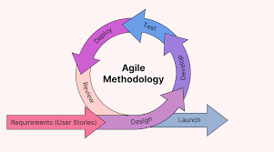

*Fig 3.1 Agile Methodology*

**3.3.1 Interview**

Interviews played a crucial role in the development of this project by providing in-depth insights from healthcare professionals. The main purposes of the interviews for this project are to:

1. Understand current practices in brain tumor detection, including existing tools and technologies.
2. Gather insights on challenges faced by medical professionals, such as limitations of current technologies and areas where machine learning could improve diagnostic processes.
3. Explore user expectations to ensure that the machine learning tool aligns with the needs of healthcare professionals.

**3.4 Tools and Techniques**

The project utilizes a variety of tools to enhance system development and functionality.

Flask is used for the backend, providing a lightweight web framework to integrate Python with web technologies and create RESTful APIs, which is essential for quick iterations in a research-driven environment.

The frontend is built using HTML and CSS, ensuring a user-friendly interface for healthcare professionals to easily interact with the system, upload MRI images, view results, and access reports.

Kaggle serves as the primary source for datasets, offering high-quality MRI images needed for training and validating the machine learning models. For image processing and training deep learning models, TensorFlow is employed, utilizing its tools for building and optimizing Convolutional Neural Networks (CNNs).

Seaborn and Matplotlib are used for effective data visualization, presenting training results and model performance metrics, such as confusion matrices and ROC curves. NumPy plays a critical role in handling large multi-dimensional arrays and matrices, supporting image data preprocessing to ensure efficient and effective data manipulation for machine learning models.

**Dataset used:**

The dataset used for this project is a combination of the following three datasets gotten from Kaggle:

1. Figshare ()
2. SARTAJ dataset()
3. Br35H()

This dataset contains 7,023 images of human brain MRI images which are classified into 4 classes: glioma - meningioma - no tumor and pituitary.

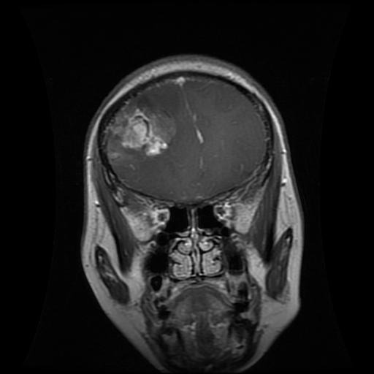

*Fig 3.2 Giloma*

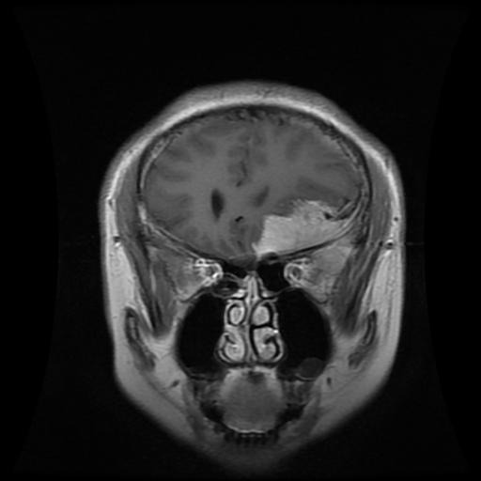

*Fig 3.3 Meningioma*

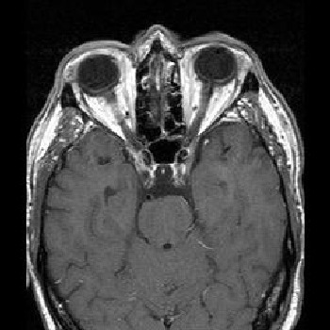

*Fig 3.4 No Tumor*

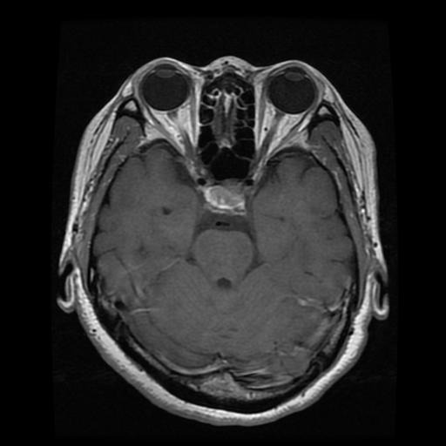

*Fig 3.5 Pituitary*

**Training Techniques**

The project begins with data preparation, where MRI images are organized into distinct directories for training and testing, categorized by tumor types such as glioma, meningioma, and pituitary, along with non-tumor samples. To enhance model robustness, data augmentation techniques are employed using ImageDataGenerator, which applies various transformations like rotation, flipping, and zooming to artificially expand the dataset and improve generalization.

The core of the system is a deep learning model, implemented as a Sequential model in frameworks like TensorFlow. This model architecture consists of multiple layers, including convolutional layers for feature extraction, pooling layers for dimensionality reduction, flatten layers to prepare data for fully connected layers, dropout layers to prevent overfitting, and dense layers for final classification.

The model is then compiled with carefully chosen optimizers, and a suitable loss function such as categorical cross-entropy. Training proceeds using the fit() and fit_generator() method, where the model learns from the augmented training data over multiple epochs. Key hyperparameters such as batch size, learning rate, and the number of epochs are fine-tuned to achieve optimal performance. Throughout this process, the model gradually improves its ability to accurately detect and classify brain tumors from MRI images.

**3.5 Ethical Considerations**

Ethical considerations are paramount in this project, particularly due to the sensitive nature of medical data and the potential implications of deploying machine learning technologies in healthcare. This section outlines the key ethical issues that must be addressed throughout the project lifecycle, ensuring that the development of this project adheres to ethical standards and promotes trust among users.

1. Patient Privacy and Data Protection: The project prioritizes patient privacy by ensuring anonymization of patient data, ensuring all identifiers are removed from MRI images and metadata to protect individual’s identities.

2. Informed Consent: Obtaining informed consent from participants is crucial when collecting data for research purposes.

3. Bias and Fairness: To mitigate bias in machine learning models, efforts will focus on using diverse datasets that represent various demographics (e.g., age, gender, ethnicity) to ensure fairness in predictions. Additionally, bias assessments will be regularly conducted to evaluate model performance across demographic groups, with adjustments like re-sampling or parameter tuning implemented if biases are detected.

4. Accountability and Transparency: A structured feedback mechanism will allow healthcare professionals to report discrepancies between model predictions and clinical outcomes, ensuring continuous model improvement and maintaining accountability.

5. Impact on Clinical Practice: The system will be integrated into clinical practice through training for healthcare professionals, continuous system performance monitoring, and careful integration into existing workflows to enhance diagnostics without disrupting established practices.

6. Ethical Use of AI in Healthcare: As artificial intelligence becomes increasingly integrated into healthcare, ethical considerations surrounding its use are still a concern.

**3.6 Requirement Analysis**

**3.6.1 Hardware Requirements**

1. i5 intel 8th Gen Processor
2. 8 GB RAM
3. 1 TB Hard Disk
4. 4 GB Nvidia GPU
5. Monitor

**3.6.2 Software Requirements**

1. Windows 10
2. Web Browser
3. Python Package Manager
4. IDE (Visual Studio)

**3.7 Requirements Specifications**

**3.7.1 Functional Requirements**

*Table 3.1 Functional Requirements*

| **Requirement Number** | **Description** |
| --- | --- |
| FR-1 | The system should process MRI and CT images to identify potential brain tumors. |
| FR-2 | The model should detect and classify tumors into categories (e.g., benign, malignant). |
| FR-3 | The system should have a user-friendly interface for clinicians to upload images and view results. |
| FR-4 | The system should generate comprehensive reports detailing findings, including images and annotations. |

**3.7.2 Non** **Functional Requirements**

*Table 3.2 Non-Functional Requirements*

| **Requirement Number** | **Description** |
| --- | --- |
| NFR-1 | The system should ensure high availability, with uptime of 99.9% to support continuous clinical use. |
| NFR-2 | The system should process images and provide results within 5 minutes to meet clinical needs. |
| NFR-3 | The system should have an intuitive user interface, allowing users to navigate and operate the system with minimal training. |
| NFR-4 | The system should comply with data protection regulations to ensure patient confidentiality. |
| NFR-5 | The system should maintain a response time of less than 2 seconds for user interactions. |
| NFR-6 | The system should be scalable to handle increased data volumes as more images are processed. |
| NFR-7 | The system must provide detailed logging of all interactions for auditing and compliance purposes. |
| NFR-9 | The model should ensure high accuracy rates (above 90%) in tumor detection across diverse datasets. |

**3.8 System Design**

The system design for this **model** is structured to provide a seamless integration of various components that work together for accurate tumor detection. Together, these components form an integrated system designed to assist healthcare professionals in detecting brain tumors with high accuracy, while ensuring that the system remains user-friendly and reliable for clinical use.

**3.8.1 System Architecture**

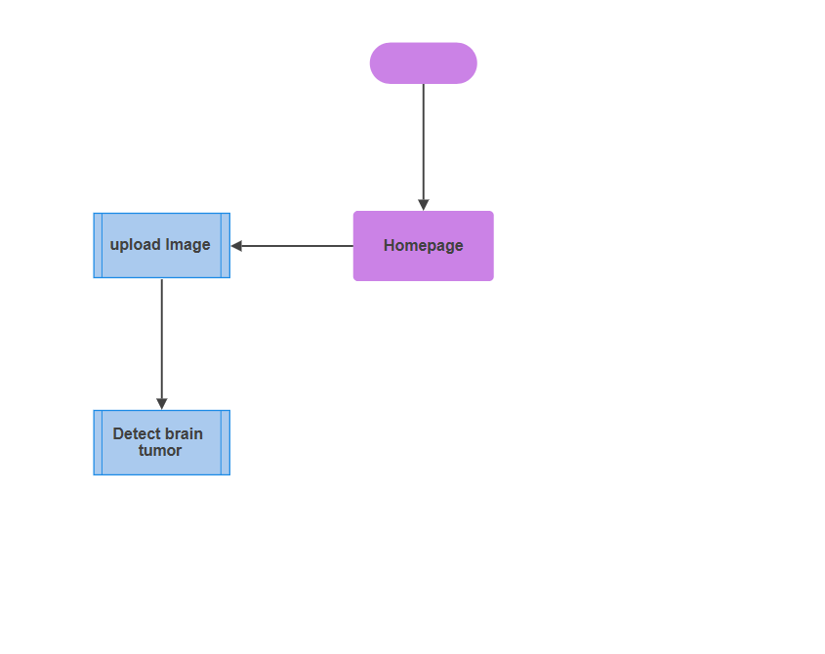

*Fig 3.6 System Architecture*

**3.8.2 Use Case**

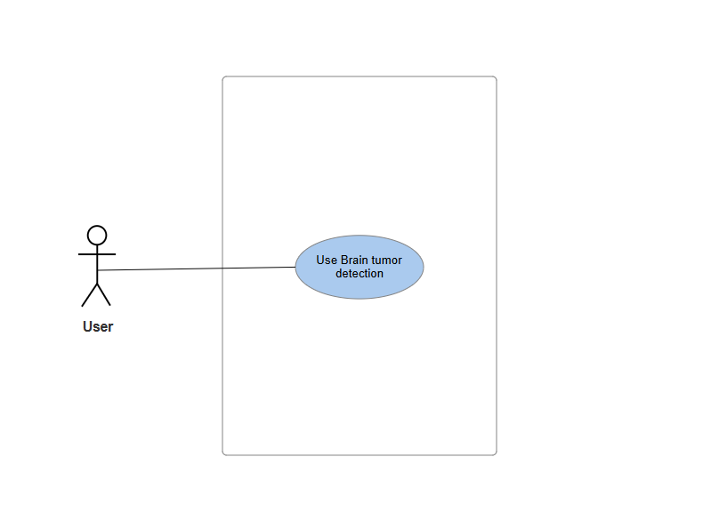

*Fig 3.7 Use Case diagram*

**Use Case: Brain Tumor Detection**

*Table 3.3 Use case description*

| **Attribute** | **Description** |
| --- | --- |
| **Use Case Name** | Brain Tumor Detection |
| **Description** | This use case describes how the system detects a brain tumor from an uploaded MRI image using machine learning models. |
| **Actors** | - User: Medical professionals or patients uploading MRI images for tumor detection.  - System: Machine learning model integrated into the web app for brain tumor detection. |
| **Preconditions** | 1. The user must be logged into the web application.  2. The user has an MRI image of the brain available for upload.  3. The machine learning model is deployed and integrated with the system. |
| **Postconditions** | The system displays the result of the tumor detection, including whether a tumor is present and the type of tumor (if applicable). |
| **Main Flow** | **User**:  1. The use case begins when the user uploads an MRI image of the brain into the system. |
| **System** | 1. The system processes the uploaded MRI image using the pre-trained machine learning model.  2. The system analyzes the image to detect any tumors present.  3. The system provides the detection results, including whether a tumor is present, and classification. 4. The system displays the result on the user interface, along with confidence levels. |
| **Exception Condition** | **“No Tumor Detected”**: If no tumor is detected in the MRI image, the system displays a message: "No tumor detected in the MRI image."  **“Error in Detection”**: If the system fails to process the image or encounters an error, it displays an error message: "Error in tumor detection. Please upload a valid MRI image." |
| **Alternative Flow** | 1. If the uploaded MRI image is not in the correct format, the system prompts the user to upload a valid image file (e.g., JPG, PNG).  2. If the system is unable to detect any tumors, the user may choose to upload a different image or consult a medical professional for further analysis. |

**3.8.3 Dataflow Diagram**

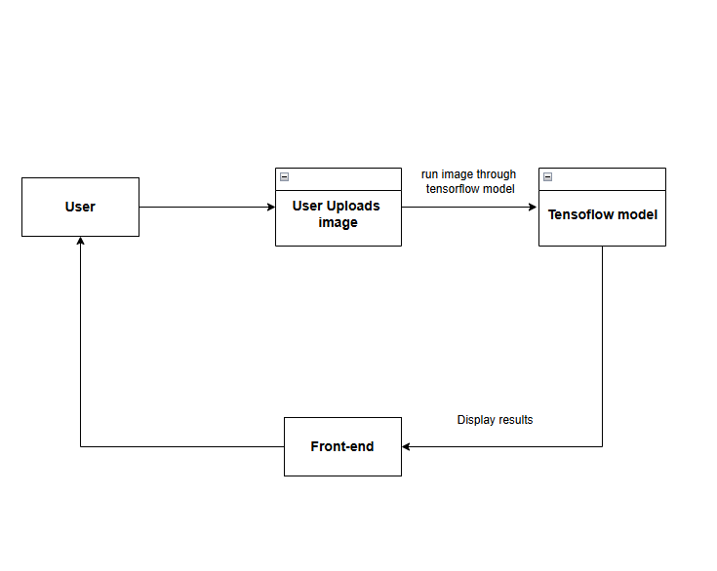

*Fig 3.8 Data flow diagram*

**3.8.4 Activity Diagram:**

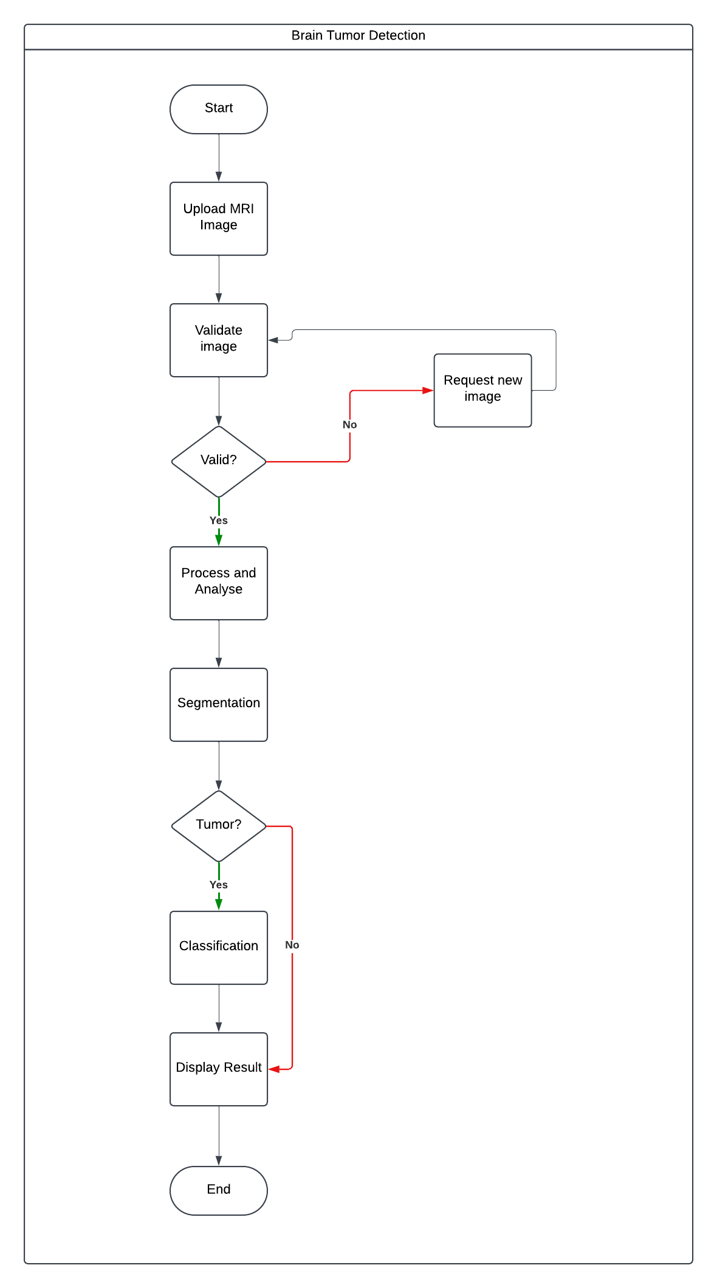

*Fig 3.9 Activity diagram*

**3.8.5 User Interface**

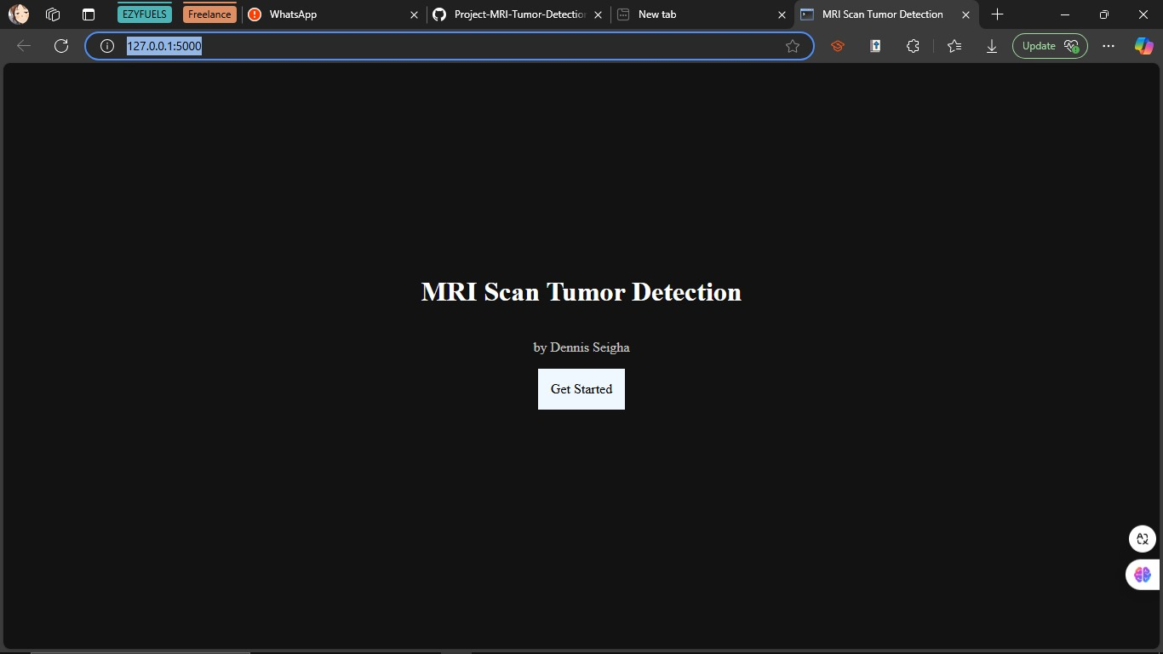

*Fig 3.10 UI 1*

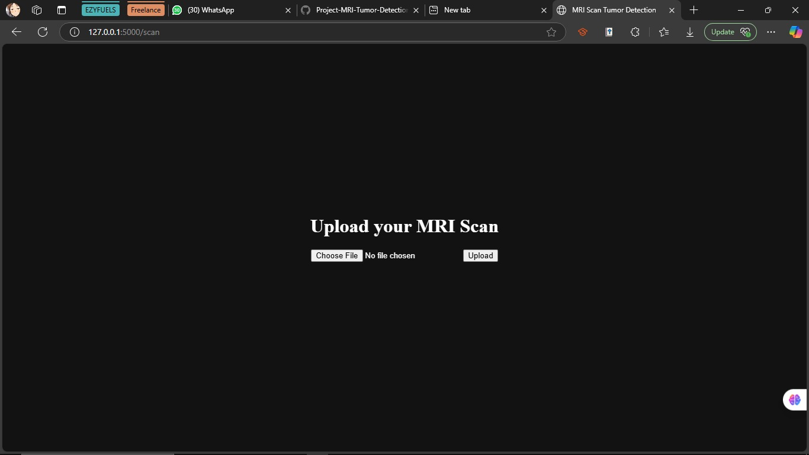

*Fig 3.11 UI 2*

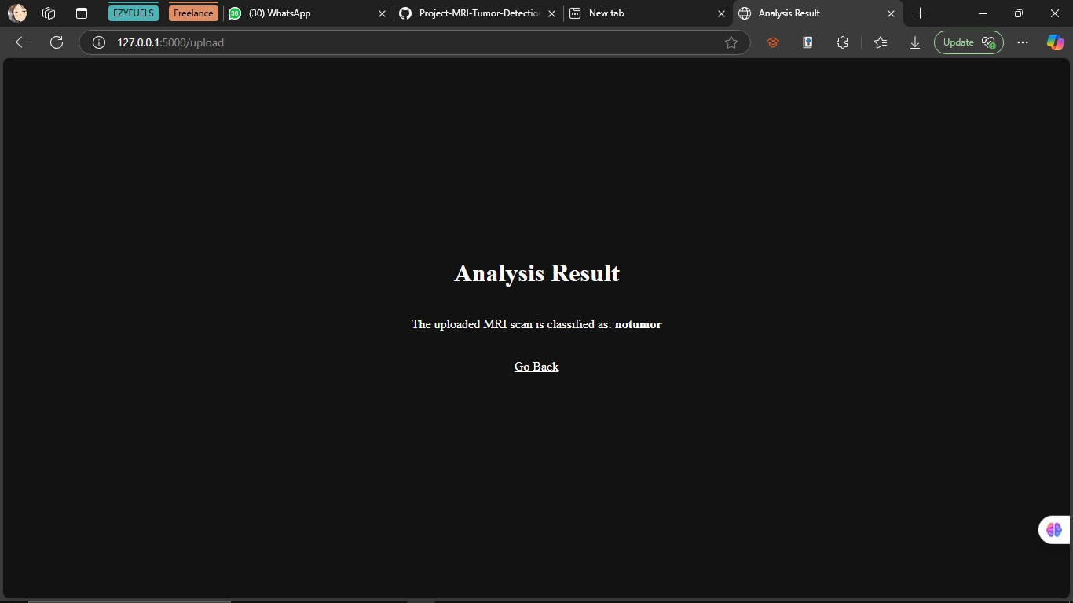

*Fig 3.12 UI 2*

**CHAPTER FOUR**

**IMPLEMENTATION AND TESTING**

**4.1 Overview**

The implementation phase of the Brain Tumor Detection Using Machine Learning project involved translating the design specifications into a functional system. This process involved data preparation, model development, training, and integration into a user-friendly interface. The testing phase rigorously evaluated the system's performance, accuracy, and usability to ensure it met the project's objectives and also a user guide on how to use the system.

**4.2 Main Features**

1. Image Processing and Enhancement:
   * The project used Implemented advanced preprocessing techniques to improve MRI image quality.
   * Utilized contrast enhancement and noise reduction algorithms to highlight tumor regions.
2. Deep Learning Model:
   * Developed a convolutional neural network (CNN) architecture optimized for brain tumor detection.
3. Multi-class Classification:
   * Enabled the system to classify tumors into multiple categories (e.g., glioma, meningioma, pituitary).
4. User Interface:
   * Created an intuitive web-based interface for clinicians to upload MRI scans and view results.
   * Integrated visualization tools to highlight detected tumor regions on the original image.

**4.3 IMPLEMENTATION PROBLEMS**

1. Data Scarcity and Imbalance:
   * Limited availability of high-quality, labeled MRI datasets for rare tumor types.
   * Uneven distribution of samples across different tumor categories.
2. Integration Challenges:
   * Difficulties in seamlessly integrating the machine learning model with the user interface.

**4.4 Overcoming Implementation Problems**

1. Addressing Data Issues:
   * We gathered dataset from multiple sources
   * We Implemented data augmentation techniques to artificially expand the dataset.
   * Utilized transfer learning to leverage knowledge from larger, related datasets.

**4.5 TESTING**

The test plans for the brain tumor detection system using machine learning outline the objectives of testing and specify the critical components to be evaluated. The primary goal is to ensure that all key features: image preprocessing, tumor detection and classification, are integrated correctly and that the application functions as a cohesive unit.

**4.5.1 Test Plans**

*Table* 4.1 Test cases summary

|  |  |  |  |  |  |  |
| --- | --- | --- | --- | --- | --- | --- |
| **Test Type** | **Test Case** | **Description** | **Input** | **Process** | **Expected Output** | **Assertion** |
| Unit Testing | Model Prediction | Validate tumor classification | Pre-processed MRI image of known tumor | Feed image to trained model | Correct tumor classification | Predicted class matches known type |

|  |  |  |  |  |  |  |
| --- | --- | --- | --- | --- | --- | --- |
| Integration Testing | Image Processing Pipeline | Test end-to-end workflow | Raw MRI image file | Preprocess → Model prediction | Predicted Result | Each step executes without errors, final result accurate |
| Integration Testing | UI-Backend Integration | Verify user upload and result display | User uploads image via web interface | Frontend → Backend processing → Frontend display | Results displayed on UI | Correct results shown within 10 seconds of upload |
| System Testing | Accuracy Evaluation | Measure overall system accuracy | Large, diverse test dataset (500+ images) | Process entire dataset through system | High accuracy across all tumor types | Overall accuracy > 95%, F1-score > 0.90 for each class |
| System Testing | Cross-platform Compatibility | Check system on different browsers/devices | Access system from Chrome, Firefox, Safari on desktop and mobile | Perform standard workflow on each platform | Consistent functionality across platforms | All features work correctly on each tested platform |

**4.6 Results**

After system testing was done which included using a variety of new MRI images and it performed well, the following results were collated;

Accuracy: the accuracy came to be between 90% and 100% for the training set and 85% to 90% for the validation set as shown below:

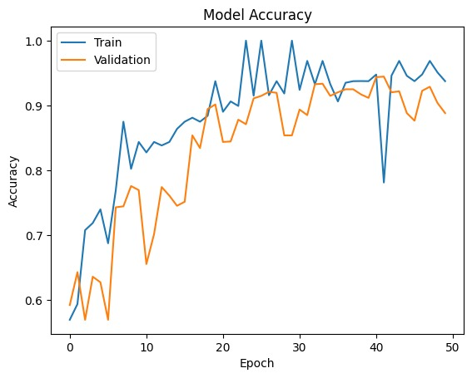

*Fig 4.1 Model Accuracy*

Model Loss: The Training loss was just below 0.2 and the Validation loss around 0.3 as shown below.

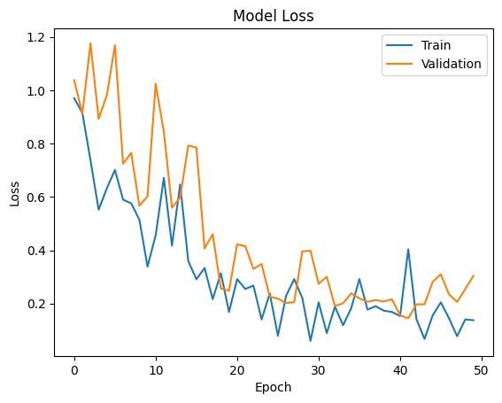

*Fig 4.2 Model Loss*

Confusion Matrix: The model performs well overall, particularly in the **notumor** category, with 403 true positives and minimal misclassification, as only 2 instances are predicted as glioma. **Glioma** and **pituitary** tumors are also classified effectively, with few misclassifications. However, the model struggles most with **meningioma**, where it is often confused with other tumor types, particularly glioma and notumor. Additionally, there are some false negatives for **meningiomas** (52) and **pituitary tumors** (2), suggesting that there is room for improvement in accurately detecting these categories.

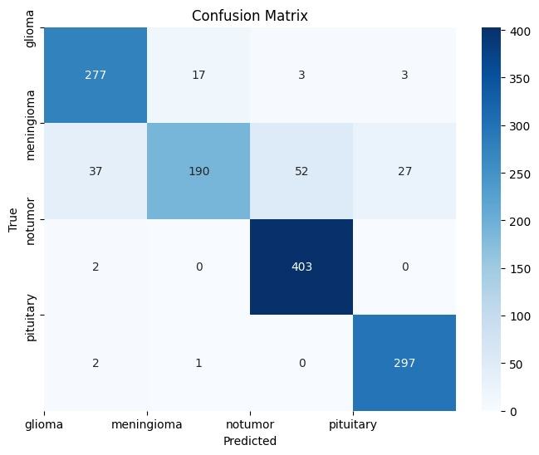

*Fig 4.3 confusion matrix*

For the Recall, Precision and F1scores;

*Table 4.1 Model scores*

| **Class** | **Precision (%)** | **Recall (%)** | **F1-Score (%)** |
| --- | --- | --- | --- |
| Glioma | 87.11 | 92.33 | 89.64 |
| Meningioma | 91.35 | 62.09 | 73.93 |
| No Tumor | 87.99 | 99.51 | 93.40 |
| Pituitary | 90.83 | 99.00 | 94.74 |

**4.7 User Guide**

**1. Accessing the Web Application:**

* Open the web application in your preferred browser by visiting the provided URL.

**2. Uploading MRI Images:**

i. **Home Screen**:

* The home screen will display a simple interface for uploading your MRI images for analysis.  
  ii. **Upload Image**:
* Click the **Upload Image** button on the home page.
* Select the MRI image file from your computer. Supported formats: JPG, PNG, and DICOM.  
  iii. **Upload**:
* After selecting your image, click the **Upload** button to start the analysis process.

**3. Viewing the Analysis Results:**

* Once the image is uploaded, the model will analyze the MRI scan and return a classification.
* The result will show whether the image is classified as:
  + **Glioma**
  + **Meningioma**
  + **Pituitary Tumor**
  + **No Tumor**

**4. Repeat the Process:** You can upload additional MRI images by returning to the **Home Screen** and repeating the upload process.

**4.8 Summary**

This chapter has addressed key challenges encountered during the development and integration of the AI-based brain tumor detection system using machine learning. The system underwent multiple iterations to meet both functional and non-functional requirements, ensuring reliable performance in detecting and classifying brain tumors from MRI images. Tests were conducted to evaluate the accuracy of the model’s predictions, including tumor classification. Solutions were developed to ensure the system meets the needs of healthcare professionals, with a focus on usability, accuracy, and the real-time processing of medical images. The system is now positioned to provide valuable assistance in diagnosing brain tumors, with potential for broader adoption in healthcare settings.

**CHAPTER FIVE**

**DISCUSSIONS AND RECOMMENDATIONS**

**5.1 OVERVIEW**

This chapter delivers an in-depth analysis of the results from the brain tumor detection project, assessing the goals met, recognizing the limitations and obstacles encountered during the execution, suggesting potential improvements, and providing recommendations for additional research and development. The knowledge acquired from this project aids the ongoing endeavors to enhance diagnostic precision and efficiency within clinical environments.

**5.2 OBJECTIVE ASSESSMENT**

The primary objectives of this project was to develop a machine learning-based system capable of accurately detecting and classifying brain tumors from MRI images. The system successfully achieved high accuracy rates across multiple tumor types, demonstrating effective preprocessing techniques and robust model performance. Key metrics such as precision, recall, and F1-score indicate that the system can reliably assist clinicians in diagnosing brain tumors, thereby enhancing decision-making processes in healthcare.

**5.3 LIMITATIONS AND CHALLENGES**

Despite the successes of this project, several limitations and challenges were encountered:

1. **Data Limitations**: The availability of high-quality, labeled datasets for rare tumor types was limited.
2. **Model Complexity**: The deep learning model's complexity required significant computational resources for training and inference, which could be a barrier in resource-constrained environments.
3. **Integration Issues**: Initial plans for a mobile application faced compatibility issues with the model format, leading to a shift toward a web-based solution.
4. **Overfitting Risks**: Although measures were taken to mitigate overfitting, there remains a risk that the model may not perform well on unseen data.

**5.4 FUTURE ENHANCEMENTS**

To address the limitations identified and improve the system's capabilities, several enhancements are recommended:

1. **Data Augmentation**: Implement more sophisticated data augmentation techniques to artificially expand the dataset and improve model robustness.
2. **Transfer Learning**: Explore additional transfer learning strategies using larger pre-trained models to enhance detection accuracy for rare tumor types.
3. **Real-Time Processing**: Develop optimizations for real-time image processing to facilitate immediate diagnostic feedback in clinical settings.
4. **User Interface Improvements**: Enhance the user interface for better usability and accessibility for clinicians.

**5.5 RECOMMENDATIONS**

Based on the findings from this project, the following recommendations are proposed:

1. **Collaborative Data Sharing**: Encourage collaboration among medical institutions to create larger, more diverse datasets that can improve model training and validation.
2. **Continuous Model Training**: Establish protocols for continuous model training with new data to adapt to evolving diagnostic needs and improve accuracy over time.
3. **Integration with Clinical Workflows**: Work closely with healthcare professionals to ensure that the system integrates seamlessly into existing clinical workflows, enhancing adoption rates.

**5.6 SUMMARY**

In summary, this chapter has discussed the successful outcomes of the brain tumor detection project while acknowledging its limitations and challenges. The project has demonstrated that machine learning can significantly aid in diagnosing brain tumors from MRI images, providing a valuable tool for clinicians. Future enhancements and recommendations aimed at improving data quality, model performance, and user experience will contribute to advancing this important area of medical technology.

**REFERNCES**

Birajdar, M. (2023). Brain Tumor Detection Using Machine Learning with CNN Algorithm. *International Journal for Research in Applied Science and Engineering Technology*, *11*(12), 1099–1102. https://doi.org/10.22214/ijraset.2023.57529

Brindha, P. G., Kavinraj, M., Manivasakam, P., & Prasanth, P. (2021). Brain tumor detection from MRI images using deep learning techniques. *IOP Conference Series Materials Science and Engineering*, *1055*(1), 012115. https://doi.org/10.1088/1757-899x/1055/1/012115

Chauhan, S., Parchure, S., & Scott, J. (2023). Comparing Machine Learning Models to Determine Which is Most Effective at Detecting Brain Tumors. *Journal of Student Research*, *12*(1). https://doi.org/10.47611/jsrhs.v12i1.3999

Ghemosu, D., & Joshi, S. R. (2021). Detection and classification of MRI-Based brain tumor via JAYA algorithm and Twin support vector machine. *Journal of Science and Engineering*, *9*, 31–42. https://doi.org/10.3126/jsce.v9i9.46299

Goyal, D., & Sharma, H. (2023). Brain tumor detection system using neural networks. *International Journal of Communication and Information Technology*, *4*(1), 59–63. https://doi.org/10.33545/2707661x.2023.v4.i1a.61

Hollon, T. C., Lewis, S., Pandian, B., Niknafs, Y. S., Garrard, M. R., Garton, H., Maher, C. O., McFadden, K., Snuderl, M., Lieberman, A. P., Muraszko, K., Camelo-Piragua, S., & Orringer, D. A. (2017). Rapid intraoperative diagnosis of pediatric brain tumors using stimulated Raman histology. *Cancer Research*, *78*(1), 278–289. https://doi.org/10.1158/0008-5472.can-17-1974

Khan, F., Ayoub, S., Gulzar, Y., Majid, M., Reegu, F. A., Mir, M. S., Soomro, A. B., & Elwasila, O. (2023). MRI-Based Effective Ensemble Frameworks for Predicting Human Brain Tumor. *Journal of Imaging*, *9*(8), 163. https://doi.org/10.3390/jimaging9080163

Kumar, V., Krishna, K., & Kusumavathi, S. (2019). An Automated Method for MRI Based Brain Tumor Detection using Berkeley Wavelet Transformation and Support Vector Machine. *International Journal of Engineering and Advanced Technology*, *8*(6s3), 1062–1065. https://doi.org/10.35940/ijeat.f1175.0986s319

Lamrani, D., Cherradi, B., Gannour, O. E., Bouqentar, M. A., & Bahatti, L. (2022). Brain Tumor Detection using MRI Images and Convolutional Neural Network. *International Journal of Advanced Computer Science and Applications*, *13*(7). https://doi.org/10.14569/ijacsa.2022.0130755

Ma, Z., & Lin, Z. (2023). The classification of human brain tumors with machine learning. *Journal of Physics Conference Series*, *2580*(1), 012033. https://doi.org/10.1088/1742-6596/2580/1/012033

Manogaran, G., Shakeel, P. M., Hassanein, A. S., Kumar, P. M., & Babu, G. C. (2018). Machine Learning Approach-Based gamma distribution for brain tumor detection and data sample imbalance analysis. *IEEE Access*, *7*, 12–19. https://doi.org/10.1109/access.2018.2878276

Reszke, M., & Smaga, Ł. (2023). Machine learning methods in the detection of brain tumors. *Biometrical Letters*, *60*(2), 125–148. https://doi.org/10.2478/bile-2023-0009

Sadad, T., Rehman, A., Munir, A., Saba, T., Tariq, U., Ayesha, N., & Abbasi, R. (2021). Brain tumor detection and multi‐classification using advanced deep learning techniques. *Microscopy Research and Technique*, *84*(6), 1296–1308. https://doi.org/10.1002/jemt.23688

Saeedi, S., Rezayi, S., Keshavarz, H., & Kalhori, S. R. N. (2023). MRI-based brain tumor detection using convolutional deep learning methods and chosen machine learning techniques. *BMC Medical Informatics and Decision Making*, *23*(1). https://doi.org/10.1186/s12911-023-02114-6

Sarwar, N., Noreen, I., & Irshad, A. (2022). Development of the Tumor Diagnosis Application for Medical Practitioners using Transfer Learning. *BioScientific Review*, *4*(2), 78–93. https://doi.org/10.32350/bsr.42.05

Shrotriya, L., Agarwal, G., Mishra, K., Mishra, S., Bidwe, R. V., & Kaur, G. (2023). Brain tumor detection using advanced deep learning implementations. *Traitement Du Signal*, *40*(5). https://doi.org/10.18280/ts.400508

Srinivasalu, P., & Palaniappan, A. (2022). Brain tumor detection by modified particle swarm Optimization algorithm and Multi-Support Vector Machine Classifier. *International Journal of Intelligent Engineering and Systems*, *15*(6), 91–100. https://doi.org/10.22266/ijies2022.1231.10

Sutradhar, P., Tarefder, P. K., Prodan, I., Saddi, M. S., & Rozario, V. S. (2021). Multi-Modal Case Study on MRI Brain Tumor Detection Using Support Vector Machine, Random Forest, Decision Tree, K-Nearest Neighbor, Temporal Convolution & Transfer Learning. *AIUB Journal of Science and Engineering (AJSE)*, *20*(3), 107–117. https://doi.org/10.53799/ajse.v20i3.175

Tummala, R. (2023). A novel approach to brain tumor classification using deep neural networks. *medRxiv (Cold Spring Harbor Laboratory)*. https://doi.org/10.1101/2023.10.03.23296522

Wang, J. (2023). The role of machine learning in the detection and classification of brain tumors: A literature review of the past two years. *Computer and Information Science*, *16*(2), 20. https://doi.org/10.5539/cis.v16n2p20

# **Appendix A - Project Document**

**IN-DEPTH PROJECT DOCUMENTATION**

**Full Candidate Name:** Seigha Dennis Junior

**Student ID:** BU/22A/IT/6599

**Title:** Design And Implementation Of A Brain Tumors Detection System Using Machine Learning

**Course of Study:** B.Sc. Computer Science.

**Background and Motivation**

The brain serves as the central command of the human body, and in recent years, a variety of brain disorders have been identified. The tools for diagnosing brain diseases are becoming increasingly complex and remain a significant area for further research; however, the use of AI in diagnosing brain disorders has enhanced the precision and accuracy of disease prediction and identification. Automated methods for the non-invasive examination of brain images have become essential, as brain diseases are often life-threatening and are a major cause of mortality in developed nations. The integration of AI in brain tumor surgery can lead to safer and more effective treatment outcomes. A notable challenge remains the knowledge gap between clinical professionals and data science experts. This project originates from a need for a tool capable of automatically, scalably and cost effectively helping radiologists to detect brain tumors more precisely and in a timely manner resulting in improved patient outcome.

**Statement of the Problem**

The problem statement of this work highlights several critical issues in the detection of brain tumors using MRI scans. First, the accuracy of brain tumor detection is compromised due to the reliance on physicians to manually identify tumors, which not only affects detection accuracy but is also a time-consuming process. Second, tumor segmentation presents significant challenges because of the complex nature of brain structures, making it difficult to delineate tumor boundaries accurately. Finally, the primary challenge lies in identifying brain tumors amidst variations in tumor location, shape, size, and intensity across different patients, coupled with the often unclear and irregular boundaries of the tumors. These factors collectively underscore the need for advanced automated solutions to enhance diagnostic accuracy and efficiency in clinical practice.

# **Appendix B- Source Codes**

